**Measurement units : some statistics**

1st part : sources units

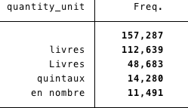

Actually, the database counts 1 585 measurement units from all the sources transcriptions.

There are 157 287 missing units among the 440 441 exchanges between France and its trade partners (it represents 35,71% of missing units).

Thereafter, these 157 287 missing units will be called “unité manquante”.

The most represented units in the database are:

2nd part : spelling consistent units

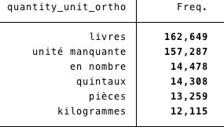

There are 655 spelling consistent units in the database, which represents a 58,68% cut from the number of sources units.

335 merchandises who have a sources unit does not have a spelling consistency one, so the spelling consistent rate reaches 99,88%.

That means that 00,12% of sources units is not transposed yet.

The most represented spelling consistent units in the database are:

3rd part : conventional units

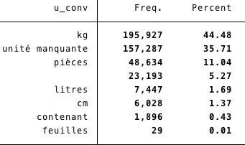

Actually, there are 6 conventional units in the database, which represents a 99,08% cut from the spelling consistent units, and a 99,62% cut from the sources ones.

23 294 merchandises who have a sources unit does not have a conventional one, so 91,77% of units from the sources have been conventionalized. That means that 8,22% of sources units are not transposed yet.

The most represented conventional units in the database are:

Conventional units by direction

There are 51 directions who record exports and imports of merchandises, but we choose to observe only conventional units by directions who appear at least a 1000 times in the database.

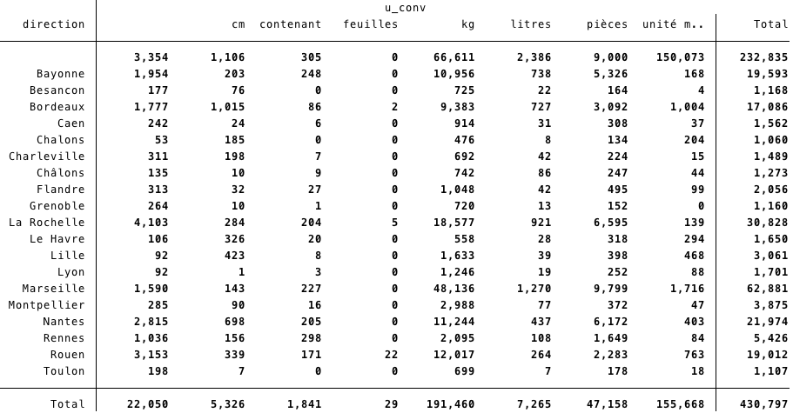

Conventional units by merchandises (SITC18 categories)

There are 24 SITC18 categories, we observe conventional units by these different categories of merchandises.

